STUDENT Joseph Roper

SALFORD CITY COLLEGE | FUTURE SKILLS

BTEC National Extended Diploma in Creative Media Production

UNIT 20: gaming hardware

Unit 20 – Task 2

# Human Computer Interface

HCI is the ways in which humans interact with computers and machines. A keyboard is one of these interactable devices where you press a key and the corresponding character will appear in a text document. A mouse is also an interactable device used with computers, when the mouse is plugged in a computer a cursor will show up on the screen which you can move around on screen by moving around the real-life counterpart and then you are able to select things on the screen by pressing a button on the mouse while the cursor is over the item you want to select. The advantages of a keyboard are that you can type faster when compared to a mouse as you can use each one of your fingers to press characters in sequence to make a word whereas with a mouse you would have to use your whole hand to select each character individually. A disadvantage of a keyboard is that it is a farce to select things as you would have to continuously press tab down until the item you want is highlighted and then press enter to select it whereas with a mouse you can just easily move your mouse to the item you want to select and click which is miles faster than the keyboard method. Overall a mouse and keyboard should be used simultaneously to make working on a computer more efficient.

[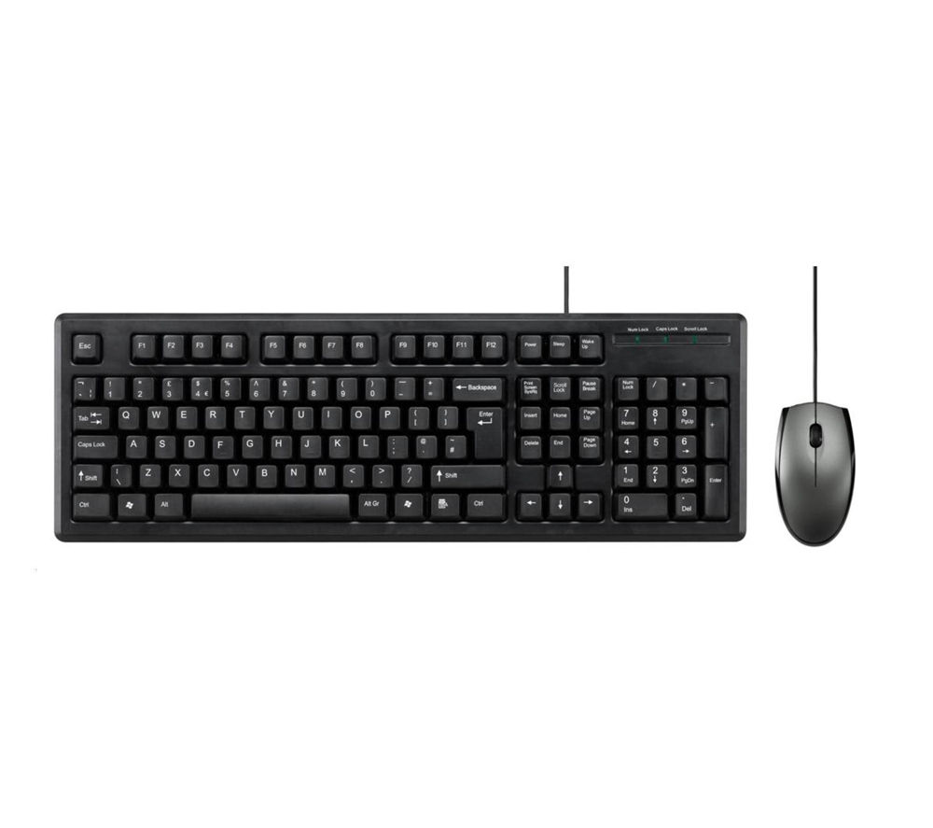](https://www.google.com/url?sa=i&source=images&cd=&ved=2ahUKEwiAr7rT2JvgAhXL8eAKHcayB80Qjxx6BAgBEAI&url=https%3A%2F%2Fwww.pcworld.co.uk%2Fgbuk%2Fcomputing-accessories%2Fcomputer-accessories%2Fmice-and-keyboards%2Fmice-and-keyboard-packages%2Fadvent-c112-keyboard-mouse-set-13212943-pdt.html&psig=AOvVaw1_Z5PM6z_cWNWuZkUtI5LA&ust=1549150278402046)

# Central Processing Unit (CPU)

The central processing unit controls nearly all the data processed in the computer. CPU’s are measured by how much data the unit can process in a second this is called clock speed. Therefore, if you want to have a good computer you would want a CPU with a high clock speed which is around 3.3 GHz so that the PC can process as many tasks at once as possible. CPU’s can have multiple cores which allow for more things to be processed because the data can be split and processed faster through the different cores. The most iconic brand of CPU’s is Intel with their i3, i5, i7 and i9 CPU’s these units are ranked in ascending order to how powerful they are basically meaning the i3 having the lowest clock speed out of all of them and i9 with the most. The cheapest one out of the list is the i3 which is used in typical office computers and laptops used to run text documents and a few websites. The i5 is used typically for home computers where people need to run multiple tasks such as games at around medium settings. The i7 is mainly used by dedicated gamers who want to run their games on high and ultra-settings and do other things that require a lot of processing power such as editing and rendering videos. Finally, the i9 is used by well off people who basically want the best running machine. To make your CPU run faster you can overclock the device to make it process data faster however this will overpower the device and cause it to run slower generally overtime from being overworked.

[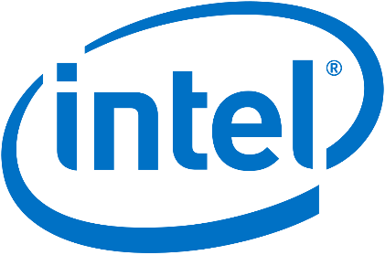](https://en.wikipedia.org/wiki/Intel)[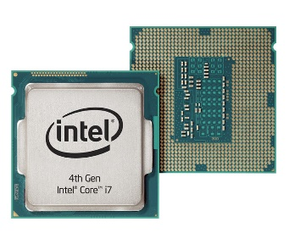](https://www.google.com/url?sa=i&source=images&cd=&ved=2ahUKEwjqiZOI2ZvgAhWkAWMBHcnWDxAQjxx6BAgBEAI&url=https%3A%2F%2Fwww.cnet.com%2Fnews%2Fintels-next-gen-quad-core-processors-tested%2F&psig=AOvVaw2VZ0jzM87fmj7-nJ_Q3362&ust=1549150381957850)

# Graphic Processing Unit (GPU)

This PC parts function is to load graphics and is appropriately named the graphics processing unit. This works like the CPU by having the computer send all the graphical data to the unit to be processed and then sent to the screen to be displayed for the user. Computers need a separate part to process graphical intensive applications such as 3D models in games as it takes a lot of processing power to render the screens display, as if the CPU did this job as well as its own the part would overload slowing down the system causing it to freeze showing a choppy or out of sync display. Many office computers that will only need to run Word documents could suffice with just a CPU as rendering text takes a small amount of processing power for the unit. GPU’s are configured differently to CPU’s resulting in faster processing speeds although because of this they are more expensive and create a lot more heat when running, to counteract this heat you would need a powerful fan or liquid cooling in your computer. The GPU can only process and render graphics unlike the CPU although in conjunction together it allows the CPU to focus on processing other data while the GPU takes the more demanding job of processing graphical data.

[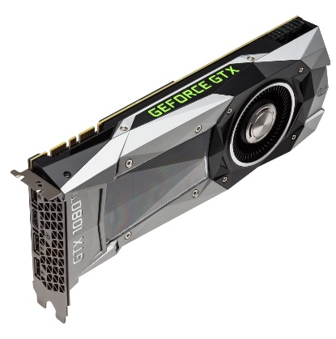](https://www.notebookcheck.net/Like-AMD-Nvidia-promises-to-ramp-up-GPU-production.282024.0.html)

# Memory (RAM)

Memory in a computer is referred to as random-access-memory or otherwise known as RAM. RAM allows data currently in use to be stored inside it for example if you open a Word document and a Google Chrome tab and constantly switch between the two while working the applications data will be stored in the RAM so that when you switch between the two the system doesn't reload the browser every time and instead remembers the data being displayed on the tab, this allows for seamless switching between applications. The data stored in the RAM throughout the time the computer has been on will be deleted as soon as the system powers down so that the next time the machine is on the RAM isn’t filled with useless data that could slow down the computer. RAM is inexpensive due to it being so easy to manufacture, they come in 4GB sticks up to 128GB although the latter is quite new and difficult to produce causing it to be a lot greater in price. Currently to run games on a computer you only really need 16GB of RAM as that is more than enough to have a smooth operating machine.

[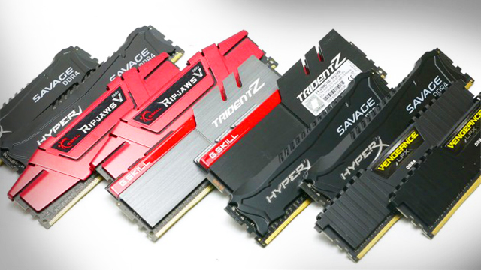](https://www.trustedreviews.com/news/what-is-ram-2950891)

# Display

There are many different displays all using different methods for projecting light to create an image using mechanical parts. These different types of displays include; LED, QLED, OLED, LCD and many more. LED screens consist of many small light-emitting diodes, commonly called pixels, all projecting a different colour of light to make up an image these are the most common forms of screens to date as they are consistent in performance, also cheap and easy to make. Some problems found with LED screens is that some of the lights cannot function properly or break causing the screen to have either a small bright dot or a black one which can be irritating to the eye as the dot of light match up to the rest of the pixels on the screen. The more LED’s on a screen result in a more focused picture, the amount of pixels displayed usually goes up like so; 240p, 360p, 480p, 720p, 1080p and now common in televisions 4000p or 4k. Screens can now be curved to make watching it more ergonomic for the viewer this is especially used in gaming so you can have a bigger screen that covers more of the in-game players perspective while also still in the real-life players point of view, basically so you can see more of the screen without having to tilt your head. Gaming monitors have better/faster processing speeds and refresh rates compared to the average TV so that the monitor will update in real time with the game allowing the player to experience no screen delay.

[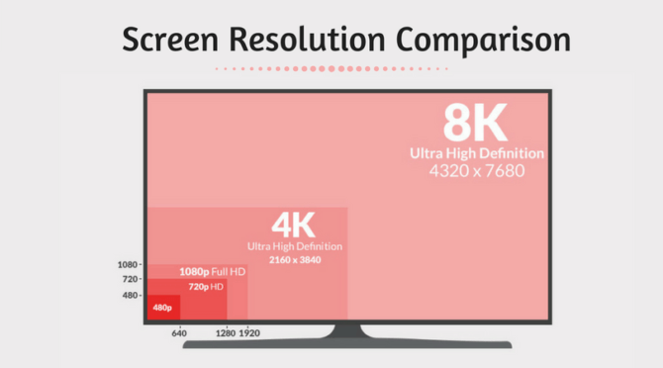](https://www.itechtics.com/screen-resolution-types-explained/)

# Sound

Sound is an important part of the computer as without it we wouldn’t be able to watch videos listen to music and be truly immersed in games. Computers are able to have sound because of the sound/audio card which is usually integrated in with the motherboard. The most commonly known way to listen to sound from a computer is with speakers or headphones which are plugged into the soundcards audio out port. Another form of connection is with Bluetooth where the sound device will connect wirelessly to the computer transferring data to and from the device with no cables, this form of connection is now very popular however for gaming it is not ideal as the connection is still not perfectly stable causing some sound delay which isn’t a problem when just listening to music but when playing games it is noticeable, therefore the best way to experience sound while gaming is with wired surround sound headphones so that you can hear things behind you and become truly immersed.

[](https://www.amazon.co.uk/headphones-earphones/b?ie=UTF8&node=4085731)

# Game Storage Medium

There have been many ways of storing data on a computer from the now inept floppy disks and disks, however, currently, the two main storage devices now are the solid-state drive (SSD) and the hard disk drive (HDD). SSD’s use flash storage which allows saving to it much faster, they also have no moving parts making them more rugged for example a pen drive is an SSD and they can spend all day moving around in your pocket with your keys and still work perfectly fine every use. SSD’s are also a lot smaller than HDD’s. Hard Drives use magnetic tape, a disk and other mechanical parts which make it slow to read and write data to it. HDD’s main pull is that they are inexpensive and can store mass amounts of data compared to SSD’s. Therefore, I believe for a perfect PC you should use a mixed system having a hard drive that stores all your media and games and then an SSD that can solely run your operating system for the best performance. Another form of storage is cloud storage which is basically storing data onto the internet, this form of storage is quite slow due to it relying on your internet speed for performance however   is a use for it and I believe this to be storing Word documents onto it as they take no storage and this allows you to access the documents from anywhere as long as you have an internet connection.

[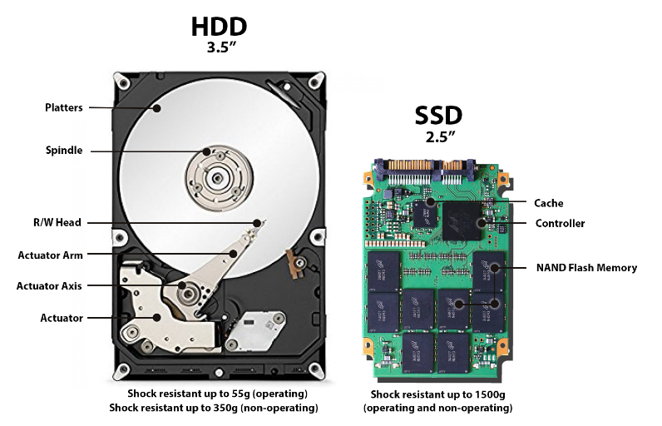](https://www.backblaze.com/blog/ssd-vs-hdd-future-of-storage/)

# Interface Devices

There are many ways in that you can interact with and control a computer these include keyboard and mouse which I have covered previously in my work and many more for example:

Voice: this is currently new to the industry and is still not perfected yet however it is pretty useful using the Amazon Alexa as an example if you want to know the time but don’t have a clock nearby you can seamlessly say “Alexa what is the time?” and the computer will respond with the current time. I find this interface device to be extremely useful in day to day life for when you have your hands full or just don’t want to move. The voice-controlled devices are affordable as well which is a massive bonus.

[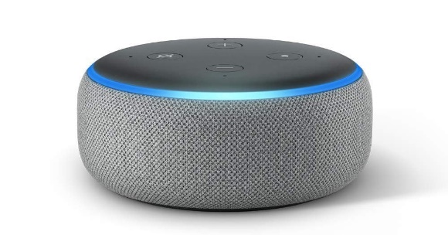](https://www.digitaltrends.com/smart-home-reviews/amazon-echo-dot-review/)

Touchscreen: touchscreen, as we all know, is when a computer reads the touch of your finger as an input this is commonly used in phones and is a lot faster to type with compared to the old phones numbered keyboard layout. Touch screen is also great as when the keyboard is not in use it can be used as an extension to the normal screen displaying more useful information to the user.

[](https://www.goodgearguide.com.au/article/355922/capacitive_vs_resistive_touchscreens/)

Movement: popularized by Nintendo with their system the WII this is where a camera will read the players real-life movement and input them into the game however incorrect that may be. This form of control was first used as a gimmick to sell consoles as the inputs were usually incorrect as the camera could never read the players movements perfectly however with Microsoft XBOX Kinect which took a different approach to Nintendo and Sony who both had their cameras read the players controller movements the Kinect’s cameras read the players entire body which meant the player didn't have to hold any external controllers and just had to stand in front of the camera and move this fitted with voice controls in the Kinect provided a fun and interesting gaming experience.

[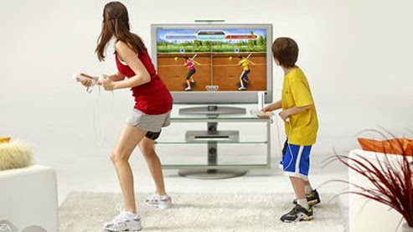](https://www.google.com/url?sa=i&source=images&cd=&ved=2ahUKEwj4vtXQ2pvgAhUD1uAKHURQD8QQjxx6BAgBEAI&url=https%3A%2F%2Fwww.nypl.org%2Fevents%2Fprograms%2F2019%2F02%2F08%2Fwii-time-and-board-games-kids&psig=AOvVaw16YsKEEv4UHdp24DOeNGmf&ust=1549150804771052)[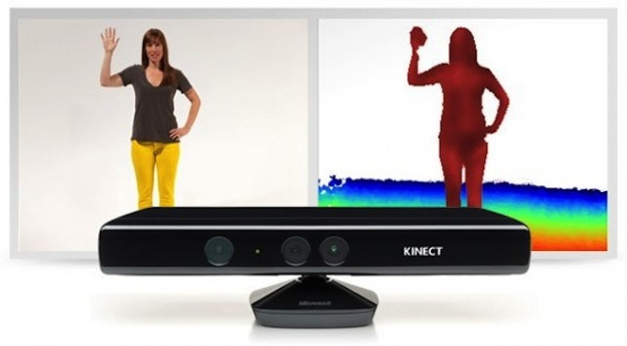](https://www.extremetech.com/gaming/230252-can-we-finally-admit-that-kinect-is-dead)

There are many more interface devices completely different from one another each covering different ways on how to interact with games to provide a better more fun experience.

# Connectivity

Connections allow you to share information between different devices.

Power Supply: This supplies every part in the computer with power so that the system can run.

Ethernet: This cable connects to the internet router and then the other end plugs into the back of the PC supplying it with broadband. This provides the PC with a strong connection and is currently better than using a wireless connection.

Audio Out Jack: This port is used by headphones and speakers to transfer digital audio to the devices so that you can listen to videos and various other things. This port is typically green.

Line in Jack: This port is a combination of the audio out jack and the microphone jack.

Microphone Port: This allows microphones to be connected to the computer to transfer audio to the PC which is then converted into digital audio. This port is typically the colour pink.

HDMI port: This stands for the High-Definition Multimedia Interface port and is plugged into your monitor or television to transfer sound and video to the screen.

VGA port (Monitor HDMI):

USB: This stands for the Universal Serial Bus port and allows devices that use the same connection to transfer data from the computer to that device. Many devices use the universal connection these include a; mouse, keyboard, pen drive, phone wire, desktop light, desktop fan and many more.

Bluetooth: this is a wireless connection typically used with wireless headphones it allows the computer to transfer data between the devices wirelessly using the Bluetooth connection.

There are many other diferent ports on a computer that alow other devises to be connected to the system.

[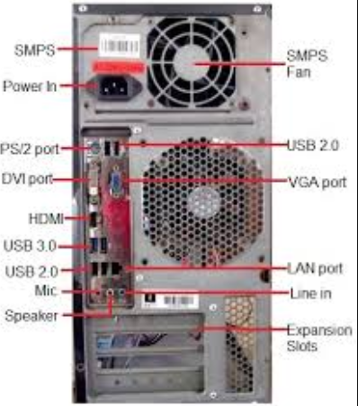](https://www.google.com/url?sa=i&source=images&cd=&ved=2ahUKEwi96o-r25vgAhWQ1-AKHXZIDaMQjxx6BAgBEAI&url=http%3A%2F%2Fwww.it4nextgen.com%2Fcomputer-connector-pc%2F&psig=AOvVaw3MwKqbG8c7ilweApvP_lTy&ust=1549150942130717)

# Power Supply

Each part in a computer's system requires different amounts of power/voltage to operate therefore computers need something to distribute the correct amount of power to each part so that the computer can run steadily, this is called the power supply it is installed into the computer and it is what connects the computer to the plug socket. The power supply generates a lot of heat as it is transferring electricity to the computer because of this the computer must have a fan blowing cool air at the computers power supply to stop the system from overheating which could cause the computer to short-circuit and set on fire. The Xbox 360 had a massive power supply in the mains wire for the system, this power brick was made externally from the system to allow it to heat up far away from the console to stop the other parts of the system overheating.

